**MODULE 5 ASSIGNMENT**

**SELECT QUERIES**

**PROBLEM 1 :**

**1. SELECT STATEMENT :**

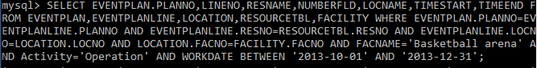

**2. RESULT :**

